The Lunascan Project - MOONWATCH - Team Report
September 30, 2011
TARGET: | SECTION 26/37 | MARE CRISIUM

MISSION PLAN:
Test LPS unit/Celestron 80GT with CMOS camera, WWV transmitter/receiver.
Camera 1 mini finder switchable to CCD camera
Camera 2 Internal
Camera 3 LPS/CMOS/LPI / Skyglobe graphics
Camera 4 HPS/CMOS/SSI / VMA graphics

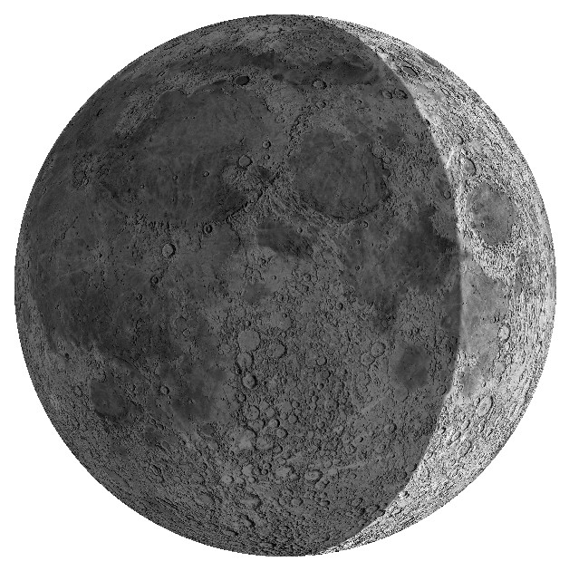
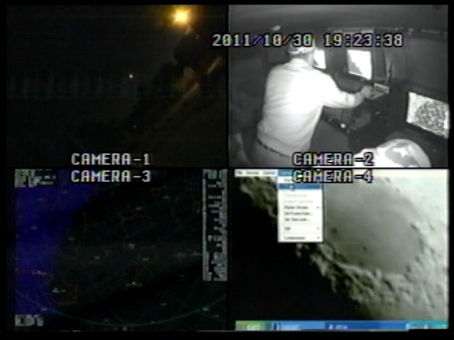
Date incorrect on Quad. S/b 2011 09 30

CAMERAS:

CAMERA ONE POSITION ON QUAD
* Finder: mini cam

CAMERA TWO POSITION
* Internal camera

CAMERA THREE POSITION

* LPS Unit
OPTICS
Celestron NexStar 80GT, 80 mm (3.1”) 400 mm f/l f/5 focal ratio; aperture video data recorder on Quad VHS1

DVR1 Sony only.

Camera used is Meade LPI/CMOs. (Meade Lunar Planetary Imager / complementary metal oxide semiconductor)
OPTICS
Celestron, 8" 2032 mm/ prime focus
Resolution 0.68 arc/sec
LPI equiv 6 mm, (90x (w/Barlow 150x)
VGA resolution (640x480) color CMOS chip
30 fps

Switchable to SKYGLOBE graphics
Digital to Analog Converter 2; TEP-100 Elite Pro II, aperture video VHS2

CAMERA FOUR POSITION

* HPS Unit 3:
CCD/SSI Camera, (Celestron Neximage Solar System Imager / Charge Coupled Device)
OPTICS
Celestron, 8" 2032 mm/ prime focus (SSI equiv 5 mm, w/Barlow 150x)
VGA resolution (640x480) color ¼” CMOS chip
30 fps
Compression 1420
Digital to Analog Converter 1; TEP-100 Elite Pro, aperture video DVR2

Switchable to

* VMA (Virtual Moon Atlas) graphics

CONFIG
Celestron C-8, no diagonal, hand control, battery eliminator on drive
Resolution 0.68 arcsec / lunar target at 0.5 degree/2160 miles wide = 0.23 miles or 1214’.

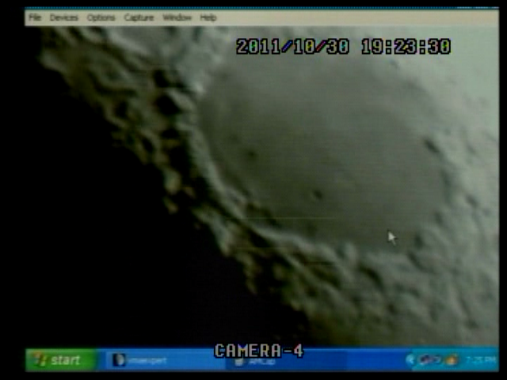

19-23-30 Mare Crisium on SSI/CCD

REPORT NOTES

VHS1 Quad
DVR1
DVR2

Date on Quad was incorrect. Times stamped at 2011 10/30 s/b 2011 09/30
LPI unit did not focus so was not used.
Imaging on Camera 4 was good
No WWV signal on any recordings.
19:45:00 (Q) Ray west of Crisium
EOS at 01H 14M elapsed
No anomalies seen or recorded.

T

