The Lunascan Project - MOONWATCH - Team Report
October 2, 2011
TARGET: | SECTION 46 | THEOPHILUS

MISSION PLAN:
Routine scans of terminator & Theophilus
Camera 1 mini finder switchable to CCD camera
Camera 2 Internal
Camera 3 CMOS/LPI / Skyglobe graphics
Camera 4 CCD / VMA graphics

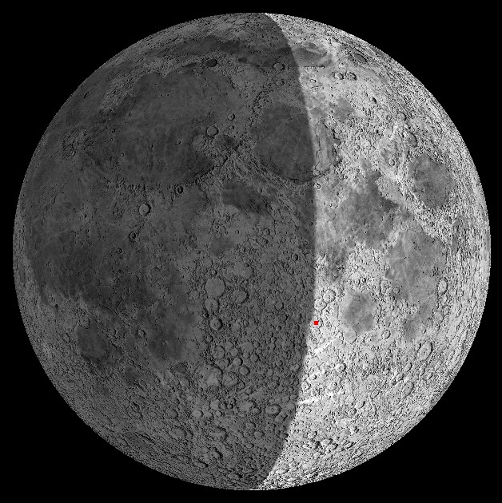
VMA Graphics
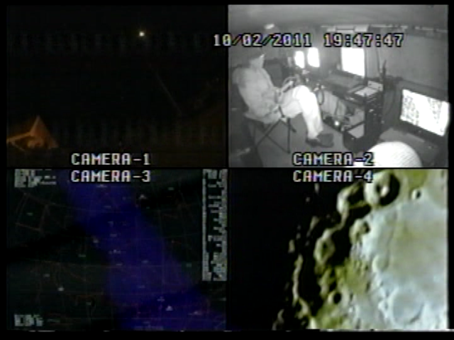

CAMERAS:

CAMERA ONE POSITION ON QUAD
* Finder: mini cam

CAMERA TWO POSITION
* Internal camera

CAMERA THREE POSITION

* LPS Unit
OPTICS
Celestron NexStar 80GT, 80 mm (3.1”) 400 mm f/l f/5 focal ratio; aperture video data recorder on Quad VHS1

DVR1 Sony only.

Camera used is Meade LPI/CMOs. (Meade Lunar Planetary Imager / complementary metal oxide semiconductor)
OPTICS
Celestron, 8" 2032 mm/ prime focus
Resolution 0.68 arc/sec
LPI equiv 6 mm, (90x (w/Barlow 150x)
VGA resolution (640x480) color CMOS chip
30 fps

Switchable to SKYGLOBE graphics
Digital to Analog Converter 2; TEP-100 Elite Pro II, aperture video VHS2

CAMERA FOUR POSITION

* HPS Unit 3:
CCD/SSI Camera, (Celestron Neximage Solar System Imager / complementary metal oxide semiconductor)
OPTICS
Celestron, 8" 2032 mm/ prime focus (SSI equiv 5 mm, w/Barlow 150x)
VGA resolution (640x480) color ¼” CMOS chip
30 fps
Compression 1420
Digital to Analog Converter 1; TEP-100 Elite Pro, aperture video DVR2

Switchable to

* VMA (Virtual Moon Atlas) graphics

CONFIG
Celestron C-8, no diagonal, hand control, battery eliminator on drive
Resolution 0.68 arcsec / lunar target at 0.5 degree/2160 miles wide = 0.23 miles or 1214’.

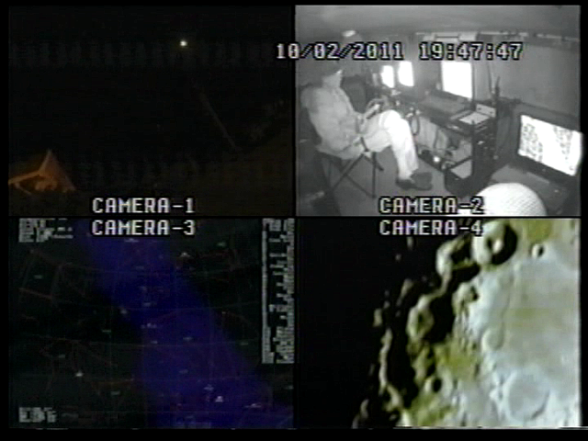

REPORT NOTES

Analysis
Quad ind 19:36:02 s/b 7:36:02 PM
Recordings on
VHS1 Quad
Good
No WWV signal
A/c scan on
Jupiter
VHS2
NIS
DVR1
19:36:16 Quad
OK but not evaluated
DVR2
Imaging on Camera 4 was OK but not as good as the CCD/SSI cam shots later on. Color too rich, signal loss, artifacts
Sky conditions very poor
WWV signal on DVR2 was very low.

Time fix at 0H 44M CUT = 1:07:38 elapsed

19-56-48 Potential “fastwalker”.

21:00:00 Atmospheric distortion near horizon. Moon scans terminated at 1H30m

Camera swung to East and targeted planet Jupiter.
21:06 Excellent images.

Inadvertantly left aperture baffle on front of C-8 and the #11 yellow Wratten filter on camera. Images of Jupiter might have been surpressed, color skewed, and moons not picked up under the low lighting conditions.

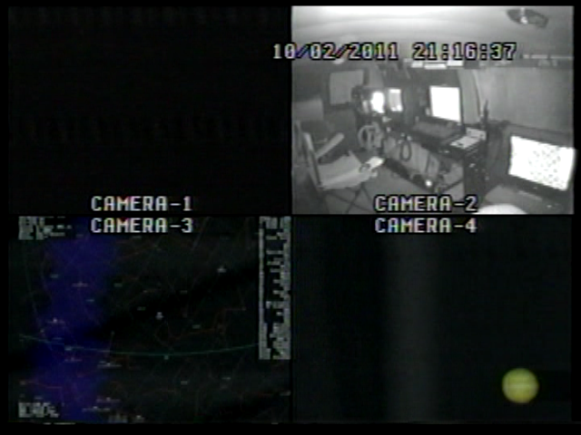

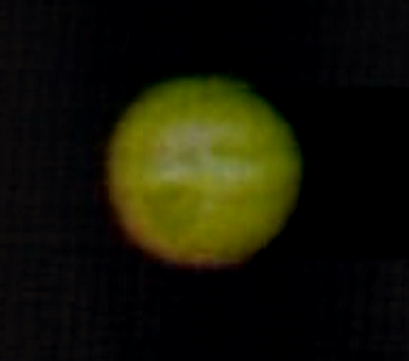

T

