The Lunascan Project - MOONWATCH - Team Report
October 2, 2011
TARGET: | SECTION 46 | THEOPHILUS

MISSION PLAN:
Routine scans of terminator & Theophilus
Camera 1 mini finder switchable to CCD camera
Camera 2 Internal
Camera 3 CMOS/LPI / Skyglobe graphics
Camera 4 CMOS/SSI / VMA graphics
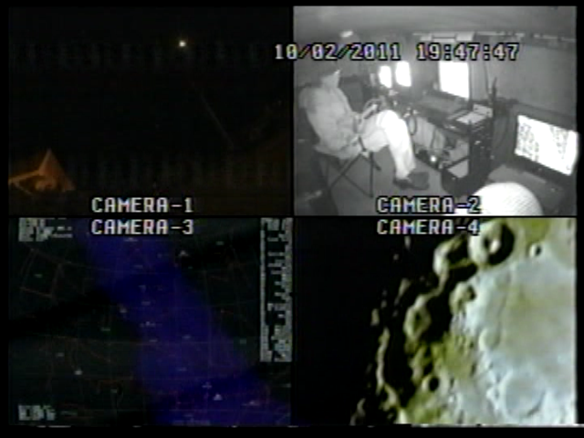

CAMERAS:

CAMERA ONE POSITION ON QUAD
* Finder: mini cam

CAMERA TWO POSITION
* Internal camera

CAMERA THREE POSITION

* LPS Unit
OPTICS
Celestron NexStar 80GT, 80 mm (3.1”) 400 mm f/l f/5 focal ratio; aperture video data recorder on Quad VHS1

DVR1 Sony only.

Camera used is Meade LPI/CMOs. (Meade Lunar Planetary Imager / complementary metal oxide semiconductor)
OPTICS
Celestron, 8" 2032 mm/ prime focus
Resolution 0.68 arc/sec
LPI equiv 6 mm, (90x (w/Barlow 150x)
VGA resolution (640x480) color CMOS chip
30 fps

Switchable to SKYGLOBE graphics
Digital to Analog Converter 2; TEP-100 Elite Pro II, aperture video VHS2

CAMERA FOUR POSITION

* HPS Unit 3:
CMOS/SSI Camera, (Celestron Neximage Solar System Imager / complementary metal oxide semiconductor)
OPTICS
Celestron, 8" 2032 mm/ prime focus (SSI equiv 5 mm, w/Barlow 150x)
VGA resolution (640x480) color ¼” CMOS chip
30 fps
Compression 1420
Digital to Analog Converter 1; TEP-100 Elite Pro, aperture video DVR2

Switchable to

* VMA (Virtual Moon Atlas) graphics

CONFIG
Celestron C-8, no diagonal, hand control, battery eliminator on drive
Resolution 0.68 arcsec / lunar target at 0.5 degree/2160 miles wide = 0.23 miles or 1214’.

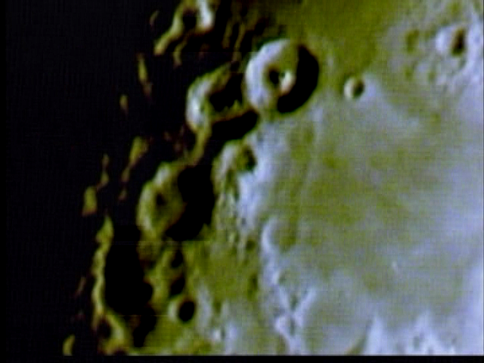

REPORT NOTES

Analysis pending
Recordings on
VHS1 Quad
VHS2
DVR1
DVR2

LPI still has problems
Imaging on Camera 4 was good
WWV signal on DVR2 was good

19-56-48 Potential “fastwalker”.

21:00:00 Atmospheric distortion near horizon. Moon scans terminated at 1H30m

Camera swung to East and targeted planet Jupiter.
21:06 Excellent images.

Inadvertantly left aperture baffle on front of C-8 and the #11 yellow Wratten filter on camera. Images of Jupiter might have been surpressed, color skewed, and moons not picked up under the low lighting conditions.

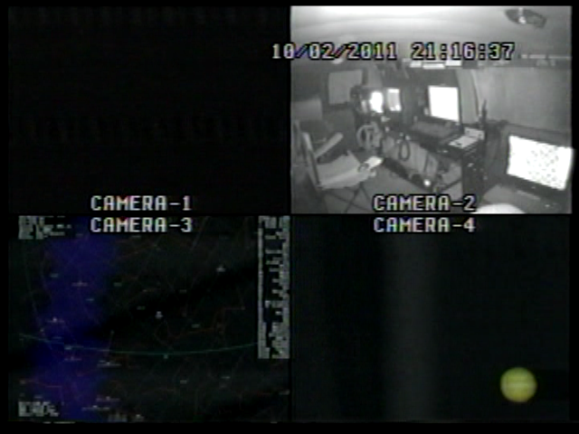

SECTION DESCRIPTION
From the north, this area is penetrated by the edge of Mare Tranquilitatis with the shallow rilles Rimae Hypatia. The large 100 km (62 mile) crater Theophilus is one of the most spectacular formations on the Moon. It forms a prominent trio with the craters Cyrillus and Catharina (Section 57). Theophilus is 14,000 feet deep with massive walls and has broken into a second formation. It has an imposing central mountain, 1,400 meters (4592') high with four summits. Craters Kant B and Zollner E are situated on the opposite edges of an extensive plateu which resembles a filled crater similar to Wargentin (Section 70). Refer to your Antonin Rukl lunar atlas chart, page 119. See also image with International Space Station transiting the area at bottom of page.

T

