The Lunascan Project - MOONWATCH - Team Report
November 1, 2011
TARGETS: | SECTIONS: 46 & 58 | S. of SEA of TRANQUILITY

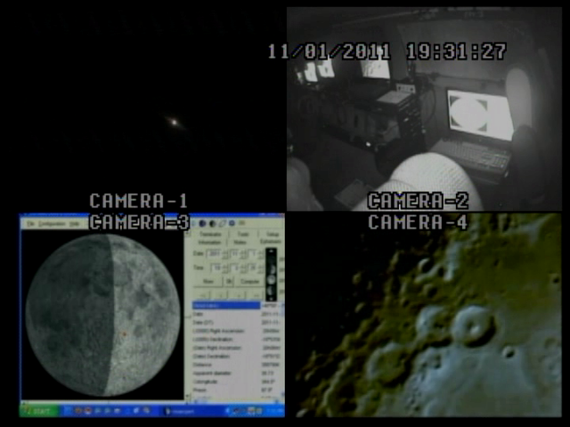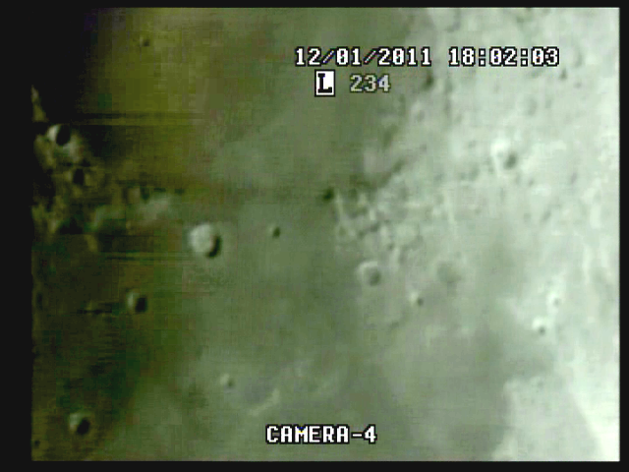

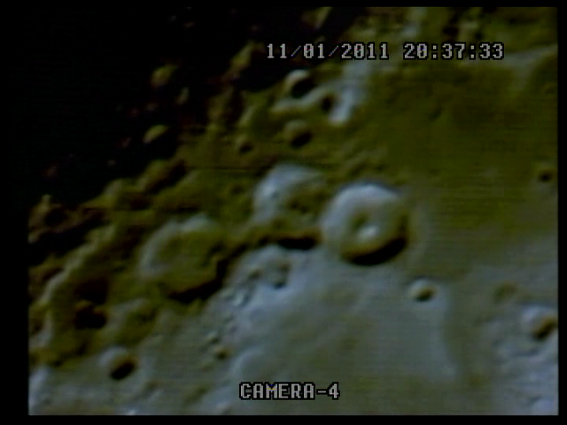

The target area is Theophillus, Cyrillus & Catharina

MISSION PLAN:
Routine scans of terminator, targeting section
Camera 1 mini finder switchable to CCD camera
Camera 2 Internal
Camera 3 LPI/CMOS/ VMA graphics.
Camera 4: SSI/CCD/ C-8.
. .
CAMERAS:

CAMERA ONE POSITION ON QUAD
* Finder: mini cam
CAMERA TWO POSITION
* Internal camera

CAMERA THREE POSITION

Compaq Presario sr1218nx computer (1)
Digital to Analog Converter 1; TEP-100 Elite Pro II
Aperture video recorder VHS2
VIRTUAL MOON ATLAS graphics

CAMERA FOUR POSITION

Dell computer
Digital to Analog Converter 2: TEP-100 Elite Pro II
Aperture video recorder DVR2
No graphics used

All camera outputs to Quad / VHS1 / Q Select DVR1

SSI Camera
CCD, (Celestron Neximage Solar System Imager / Charge Coupled Device)
OPTICS, prime focus. 5 mm
VGA resolution (640x480) color ¼” CMOS chip
30 fps
Compression 1420

LPI Camera
Not used
CMOS, (Meade Lunar Planetary Imager / complementary metal oxide semiconductor)
OPTICS, prime focus. 6 mm.
VGA resolution (640x480) color ¼” CMOS chip
30 fps
Compression 1420

Celestron C-8 SCT 8” optical tube
2032 mm f/l
F10
Resolution at lunar range = 0.68

.81086 mi or 4281.36469 feet
(30.19' X 60 = 1811.4" /.68' resol = factor of 2663.82353
2160 miles / 2663.82353 = .81086 mi resolution)

0.621 mi/km
1 m = 3.28 ‘

CONFIG
No diagonal, extended hand control DOB Driver II

REPORT NOTES

DVR1

15:36:18 Quad time BOS in error

(see below) 6:57 pm est from time check

No sound

15 42 17 Cam 3 is VMA

15 43 32 / 00h 07m 25s elapsed

20 10 09 cam 4 full screen

19 24 45 time correction 00h 27m 09s E

19 31 27 grab cap 025

check later using dvr2 elapsed

20 10 10 / 1h 12m 56 elapsed full screen finally ob quad sel

20 16 41 / 1h 19m 27s

tycho grap 026

20 39 22 / 1h 41 06s grab 028

20 39 12 / 1h 41 56s eos on q sel

check later

20 10 10 / 01h 12m 56s E

full screen finally

20 16 41 / 01h 19m 27s E

tycho grab 026

20 29 00 stop

2032 mm / 5 mm = 400x . Lunar range 396,200 km = 242,935 mi / 400 = 600 mi sim range

Target Theophilus 2.0” on CRT @ 15.0” = FOV= 450 mi

No audio on recordings by DVR 1

DVR1

No sound

DVR2

Sound, WWV signal not good

Time fix at 1h 38m CUT

1h 41m 01s elapsed

coverts to BOS =23 h 56m 59 sec CUT

15:36:07 Quad is in error

elapsed on Quad of 0h 54m19s shows Quad corrected to 19:51:31

so 6:57 PM corrected BOS:

Better images, unredacted

Grabbed scans from same periods

Cap 020

Cap 021

VHS1 Quad audio on but no sound
VHS2 Used for VMA but not saved / CMOS cam not used
DVR1 no audio
DVR2 audio but WWV weak
Command Center
Scope
Finder worked better anchored to mount rather than scope, but needs to be screwed down instead of velcroed.
Note needs to be added to op manual to
- F discs need to be in place before BOS
- Finders (both) and scope need to be aligned before BOS.
- Orientation of Moon needs to be performed before BOS.
- Due to high angle of most shots and the new mount the binoc viewer and diagonal must be used.
- Post mode sheet for DOB Driver II in cab / learn modes
- Calibrate DOB Driver II for BLASH

1. Compaq Presario sr1218nx
XP home, dvd rom, cd burner, 2.67 GHZ processor, 760 mb RAM, 80 GB hard drive
T

