The Lunascan Project - MOONWATCH - Team Report
May 11, 2012
TARGETS: | Western Half | No Specific Targets This Scan

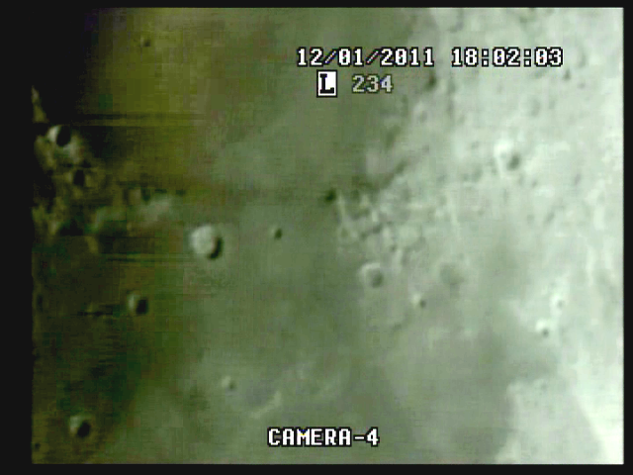
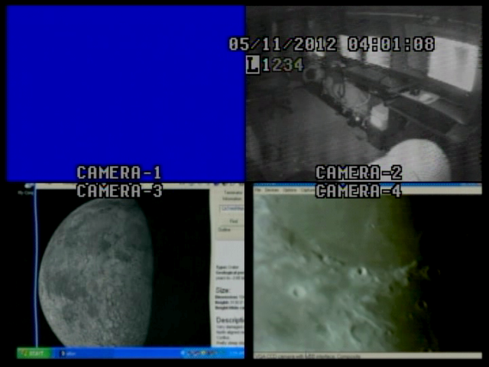

BOS 3:52:35 Quad, calibrated with Atomic Clock, but this framegrab was taken at 4:01:08 Q

MISSION PLAN:
DOB Driver II scans of terminator and to the W, targeting any objects in Western Hemisphere. Primary craters washed out as this was 1-2 days earler than optimum, but still possible imaging of anomalies or fastwalkers..
Camera 1 mini finder switchable to CCD camera
Camera 2 Internal
Camera 3 LPI/VMA graphics. (LPI not used)
Camera 4: SSI/CCD/ C-8.
. .
CAMERAS:

CAMERA ONE POSITION ON QUAD
* Finder: mini cam
CAMERA TWO POSITION
* Internal camera

CAMERA THREE POSITION

Compaq Presario sr1218nx computer (1)
Digital to Analog Converter 1; TEP-100 Elite Pro II
Aperture video recorder VHS2
VIRTUAL MOON ATLAS graphics

CAMERA FOUR POSITION

Dell computer
Digital to Analog Converter 2: TEP-100 Elite Pro II
Aperture video recorder DVR2
No graphics used

All camera outputs to Quad / VHS1 / Q Select DVR1

SSI Camera
CCD, (Celestron Neximage Solar System Imager / Charge Coupled Device)
OPTICS, prime focus. 5 mm
VGA resolution (640x480) color ¼” CMOS chip
30 fps
Compression 1420

LPI Camera
Not used
CMOS, (Meade Lunar Planetary Imager / complementary metal oxide semiconductor)
OPTICS, prime focus. 6 mm.
VGA resolution (640x480) color ¼” CMOS chip
30 fps
Compression 1420

Celestron C-8 SCT 8” optical tube
2032 mm f/l
F10
Resolution at lunar range = 0.68 /
.81086 mi or 4281.36469 feet
(30.19' X 60 = 1811.4" /.68' resol = factor of 2663.82353
2160 miles / 2663.82353 = .81086 mi resolution)

0.621 mi/km
1 m = 3.28 ‘

CONFIG
No diagonal or binoc viewer. Extended hand control DOB Driver II

REPORT NOTES

2032 mm / 5 mm = 400x . Lunar range 375,000 km = 233,000 mi / 400 = 600 mi sim range

LOS WWV audio. No recordings.

BOS 3:52:35 Quad

Time fix from DVR1 at 1:11:00 elapsed with DVR2 at 1:11:49 counters. DVR2 has 49 sec lead

Video on with target acquisition at 3m 57sec

SNS (Screen Not Set). Set at 20m35s elapsed

Quad S rec graphics off at 4:10:26 and VMA on for duration

Finder cable problem. [Remove transm from MB to Lab, place on SPU for wireless]

No tape in VCR1, neg Quad recordings

Bad picture on Qselect Mon. Reason unknown

Desktop on Mon 4 keeps shutting down but set at 120mins

DVR1

Stop

DVR2

AOS at 5m32s

Window not set

No baffle

Multiple dust mites in high light areas

Terminator shots good

No sound, good images, unredacted

Recordings on but no sound
VHS1 WWV Quad audio not recd and no tape in drive
VHS2 Used for VMA but not saved / CMOS cam not used
DVR1 no audio
DVR2 no audio
VGA computer display from Celestron CCD camera, very good.
Recording from DVR analyzed
No anomalies
FW at 31m31s elapsed / Bird
Ray on Copernicus peak needs framegrab
Cam 1 quadrant needs overlay for targeting.
Problem with reception of WWV signal from Fort Collins still an issue.

Scope
Note needs to be added to op manual to
- Balance on scope needs to be reviewed
- F discs need to be in place before BOS
- Finders (both) and scope need to be aligned before BOS.
- Orientation of Moon needs to be performed before BOS.
- Due to high angle of most shots and the new mount the binoc viewer and diagonal must be used.
- Post mode sheet for DOB Driver II in cab / learn modes
- Calibrate DOB Driver II for BLASH

1. Compaq Presario sr1218nx
XP home, dvd rom, cd burner, 2.67 GHZ processor, 760 mb RAM, 80 GB hard drive
T

