The Lunascan Project - MOONWATCH - Team Report
May 11, 2012
TARGETS: | Western Half | No Specific Targets This Scan

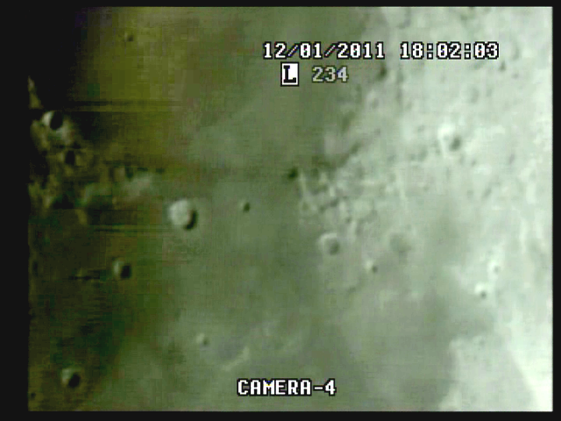

MISSION PLAN:
Routine scans of terminator, targeting Western Section
Camera 1 mini finder switchable to CCD camera
Camera 2 Internal
Camera 3 LPI/VMA graphics. (LPI not used)
Camera 4: SSI/CCD/ C-8.
. .
CAMERAS:

CAMERA ONE POSITION ON QUAD
* Finder: mini cam
CAMERA TWO POSITION
* Internal camera

CAMERA THREE POSITION

Compaq Presario sr1218nx computer (1)
Digital to Analog Converter 1; TEP-100 Elite Pro II
Aperture video recorder VHS2
VIRTUAL MOON ATLAS graphics

CAMERA FOUR POSITION

Dell computer
Digital to Analog Converter 2: TEP-100 Elite Pro II
Aperture video recorder DVR2
No graphics used

All camera outputs to Quad / VHS1 / Q Select DVR1

SSI Camera
CCD, (Celestron Neximage Solar System Imager / Charge Coupled Device)
OPTICS, prime focus. 5 mm
VGA resolution (640x480) color ¼” CMOS chip
30 fps
Compression 1420

LPI Camera
Not used
CMOS, (Meade Lunar Planetary Imager / complementary metal oxide semiconductor)
OPTICS, prime focus. 6 mm.
VGA resolution (640x480) color ¼” CMOS chip
30 fps
Compression 1420

Celestron C-8 SCT 8” optical tube
2032 mm f/l
F10
Resolution at lunar range = 0.68 /
.81086 mi or 4281.36469 feet
(30.19' X 60 = 1811.4" /.68' resol = factor of 2663.82353
2160 miles / 2663.82353 = .81086 mi resolution)

0.621 mi/km
1 m = 3.28 ‘

CONFIG
No diagonal, extended hand control DOB Driver II

REPORT NOTES

2032 mm / 5 mm = 400x . Lunar range 396,200 km = 242,935 mi / 400 = 600 mi sim range

No audio on recordings by DVR 1 or 2

No finder cable. Need to go wireless. Take transm off QuadS and use on scope finder

No tape in VCR1, no Quad recordings

No WWV signal. Need better receiver, crystal controlled if possible.

Bad picture on Qselect Mon for some reason

Desktop on Mon 4 keeps shutting down but set at 120mins

DVR1

Stop

DVR2

No sound, good images, unredacted

Recordings on but no sound
VHS1 WWV Quad audio not recd and no tape in drive
VHS2 Used for VMA but not saved / CMOS cam not used
DVR1 no audio
DVR2 no audio
VGA computer display from Celestron CCD camera, very good.
Recording from DVR analyzed
No anomalies
Cam 1 quadrant needs overlay for targeting.
Problem with reception of WWV signal from Fort Collins still an issue.

Scope
Note needs to be added to op manual to
- Balance on scope needs to be reviewed
- F discs need to be in place before BOS
- Finders (both) and scope need to be aligned before BOS.
- Orientation of Moon needs to be performed before BOS.
- Due to high angle of most shots and the new mount the binoc viewer and diagonal must be used.
- Post mode sheet for DOB Driver II in cab / learn modes
- Calibrate DOB Driver II for BLASH

1. Compaq Presario sr1218nx
XP home, dvd rom, cd burner, 2.67 GHZ processor, 760 mb RAM, 80 GB hard drive
T

