The Lunascan Project - MOONWATCH - Team Report
May 27, 2012
TARGETS: | Eastern Limb | No Specific Targets This Scan

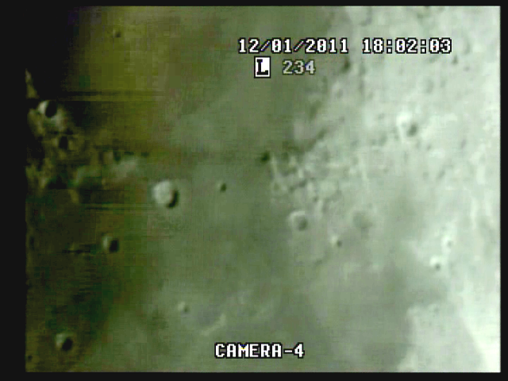

BOS

MISSION PLAN:
DOB Driver II scans of Eastern limb, test of wiring check for WWV signal, test of cargo cam recorder (VHS3). s..
Camera 1 mini finder
Camera 2 Cargo cams (1 &2)
Camera 3 LPI/VMA graphics. (LPI not used)
Camera 4: SSI/CCD/ C-8.
. .
CAMERAS:

CAMERA ONE POSITION ON QUAD
* Finder: mini cam
CAMERA TWO POSITION
* Cargo camera

CAMERA THREE POSITION

Compaq Presario sr1218nx computer (1)
Digital to Analog Converter 1; TEP-100 Elite Pro II
VIRTUAL MOON ATLAS graphics

CAMERA FOUR POSITION

Dell computer
Digital to Analog Converter 2: TEP-100 Elite Pro II
Aperture video recorder DVR2
No graphics used

All camera outputs to Quad / VHS1 / Q Select DVR1

SSI Camera
CCD, (Celestron Neximage Solar System Imager / Charge Coupled Device)
OPTICS, prime focus. 5 mm
VGA resolution (640x480) color ¼” CMOS chip
30 fps
Compression 1420

LPI Camera
Not used
CMOS, (Meade Lunar Planetary Imager / complementary metal oxide semiconductor)
OPTICS, prime focus. 6 mm.
VGA resolution (640x480) color ¼” CMOS chip
30 fps
Compression 1420

Celestron C-8 SCT 8” optical tube
2032 mm f/l
F10
Resolution at lunar range = 0.68 /
.81086 mi or 4281.36469 feet
(30.19' X 60 = 1811.4" /.68' resol = factor of 2663.82353
2160 miles / 2663.82353 = .81086 mi resolution)

0.621 mi/km
1 m = 3.28 ‘

CONFIG
No diagonal or binoc viewer. Extended hand control DOB Driver II

REPORT NOTES

2032 mm / 5 mm = 400x . = 600 mi sim range

.

BOS

WWV signal. Most impressive to date. Antenna tuned signal very well and drift was not encountered. Signal from Sennheiser Wireless Bodypack would cut out at points but time fixes were established throughout the session.

Sky conditions were murky and conditions deteriorated so seesion was terminated in less than an hour.

Buttons on recorders and clickers hard to read, should be highlighted with paint markers if possible.

DVR2
DVR1

Note needs to be added to op manual to
- Balance on scope needs to be reviewed

1. Compaq Presario sr1218nx
XP home, dvd rom, cd burner, 2.67 GHZ processor, 760 mb RAM, 80 GB hard drive
T

