The Lunascan Project - MOONWATCH - Team Report
May 30, 2012
TARGETS: | Eastern Limb | No Specific Targets This Scan

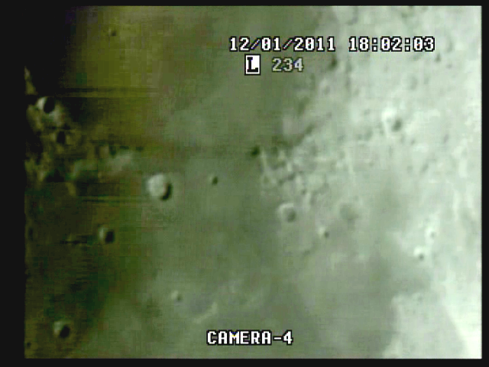
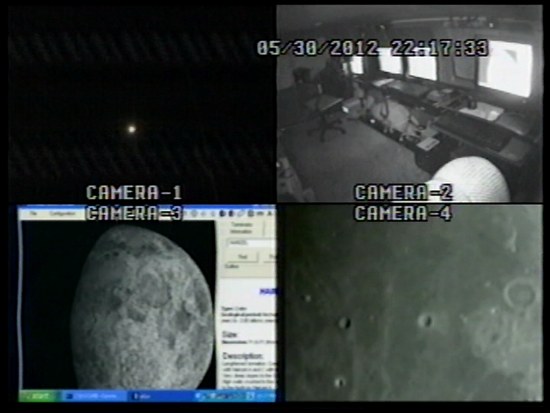

BOS

MISSION PLAN:
Routine scans with 73.4% illumination / phase 62.1
Lunar range at 363,579 km / 226.000 miles / lunation 10.09 days / colongitude 34.7
Simrange 600 miles

Start Q at 21:53:30
Target acq at 22:01:10 due to obstruction
Good imaging at 22:07:00 with good WWV

Camera 1 mini finder
Camera 2 Cargo cams (1 &2)
Camera 3 LPI/VMA graphics. (LPI not used)
Camera 4: SSI/CCD/ C-8.
. .
CAMERAS:

CAMERA ONE POSITION ON QUAD
* Finder: mini cam
CAMERA TWO POSITION
* Cargo cameras color minicam & night vision

CAMERA THREE POSITION

Compaq Presario sr1218nx computer (1)
Digital to Analog Converter 1; TEP-100 Elite Pro II
VIRTUAL MOON ATLAS graphics

CAMERA FOUR POSITION

Dell computer
Digital to Analog Converter 2: TEP-100 Elite Pro II
Aperture video recorder DVR2
No graphics used

All camera outputs to Quad / VHS1 / Q Select DVR1

SSI Camera
CCD, (Celestron Neximage Solar System Imager / Charge Coupled Device)
OPTICS, prime focus. 5 mm
VGA resolution (640x480) color ¼” CMOS chip
30 fps
Compression 1420

LPI Camera
Not used
CMOS, (Meade Lunar Planetary Imager / complementary metal oxide semiconductor)
OPTICS, prime focus. 6 mm.
VGA resolution (640x480) color ¼” CMOS chip
30 fps
Compression 1420

Celestron C-8 SCT 8” optical tube
2032 mm f/l
F10
Resolution at lunar range = 0.68 /
.81086 mi or 4281.36469 feet
(30.19' X 60 = 1811.4" /.68' resol = factor of 2663.82353
2160 miles / 2663.82353 = .81086 mi resolution)

0.621 mi/km
1 m = 3.28 ‘

CONFIG
No diagonal or binoc viewer. Extended hand control DOB Driver II

REPORT NOTES

Acq at 7m11s but not clear of obstruction

Good WWV

Time fix at 3H3m CUT = 10m4s elapsed

Images improve 13m elapsed

Clears trees

Copernicus 14m

Bird 42m32s

No anomales

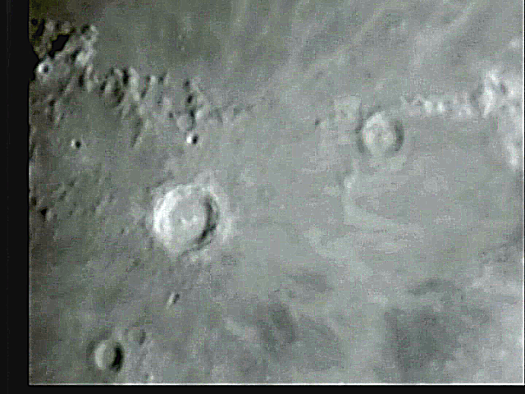

2032 mm / 5 mm = 400x . = 600 mi sim range

BOS

Sky conditions were excellent with some halo later in mission. Able to shoot the full two hours.

WWV signal very good with plenty of time fixes. Signal improved many times with arm up!!! Quad within 1-2 secs of Fort Collins time signal.

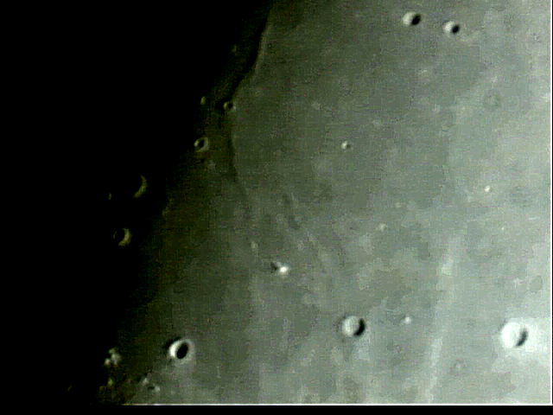

Craters at top right are Helicon & LeVerrier (Section 10 & 11). Below center is Mons La Hire (20) L-R bottom are Euler, Lambert (20) and Timocharis (21).

.

Blue instrument lights and color mini cargo cam were tested.

Aperture video VHS3 used on Cargo cams

1. Compaq Presario sr1218nx
XP home, dvd rom, cd burner, 2.67 GHZ processor, 760 mb RAM, 80 GB hard drive
T

