The Lunascan Project - MOONWATCH - Team Report
June 10, 2012
TARGETS: Multiple | Eastern Limb | Routine Targets

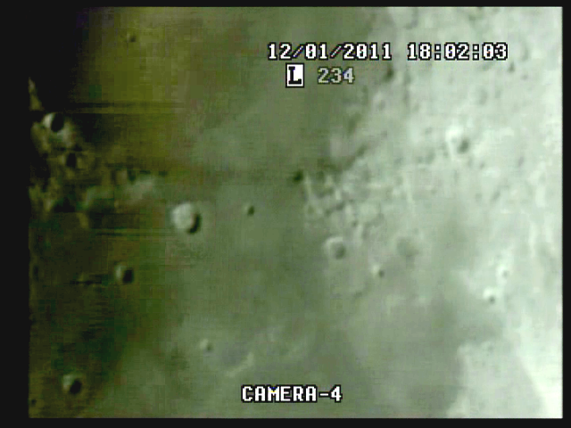

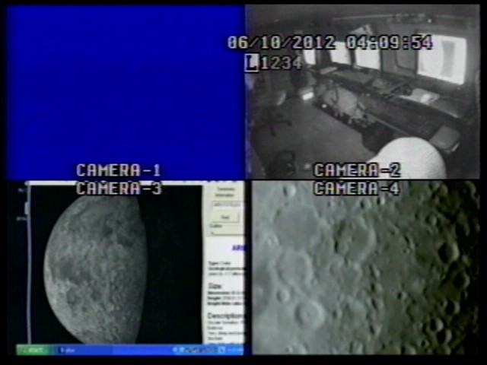

BOS 4:09 am local

MISSION PLAN:
Routine scans with 62.0 illumination
Lunar range at 386,967 km / 246,306 miles / lunation 20.27 days / colongitude 159.1
Simrange 600 miles

Quad batt fail date/time error
Says 06/09/2012 11:53:48
Time fix for Q at 8h30m CUT = 0:01:04 elapsed
Target Acq at 1m43s elapsed
EOS at 47:20s elapsed
Q time correction at 11m56s elapsed = 20120610 4:09:54 Quad
Findercam malfunction
Good imaging with good WWV

Camera 1 mini finder
Camera 2 Cargo cams (1 &2)
Camera 3 LPI/VMA graphics. (LPI not used)
Camera 4: SSI/CCD/ C-8.
. .
CAMERAS:

CAMERA ONE POSITION ON QUAD
* Finder: mini cam
CAMERA TWO POSITION
* Cargo cameras color minicam & night vision

CAMERA THREE POSITION

Compaq Presario sr1218nx computer (1)
Digital to Analog Converter 1; TEP-100 Elite Pro II
VIRTUAL MOON ATLAS graphics

CAMERA FOUR POSITION

Dell computer
Digital to Analog Converter 2: TEP-100 Elite Pro II
Aperture video recorder DVR2
No graphics used

All camera outputs to Quad / VHS1 / Q Select DVR1

SSI Camera
CCD, (Celestron Neximage Solar System Imager / Charge Coupled Device)
OPTICS, prime focus. 5 mm
VGA resolution (640x480) color ¼” CMOS chip
30 fps
Compression 1420

LPI Camera
Not used
CMOS, (Meade Lunar Planetary Imager / complementary metal oxide semiconductor)
OPTICS, prime focus. 6 mm.
VGA resolution (640x480) color ¼” CMOS chip
30 fps
Compression 1420

Celestron C-8 SCT 8” optical tube
2032 mm f/l
F10
Resolution at lunar range = 0.68 /
.81086 mi or 4281.36469 feet
(30.19' X 60 = 1811.4" /.68' resol = factor of 2663.82353
2160 miles / 2663.82353 = .81086 mi resolution)

0.621 mi/km
1 m = 3.28 ‘

CONFIG
No diagonal or binoc viewer. Extended hand control DOB Driver II

REPORT NOTES
QUAD VHS Data
BOS 4:09:54 corrected from Q batt fail error of 06/09/2012 11:53:48
Time fix at 8h30m CUT = 0:01:04 elapsed
Target Acq at 1m43s elapsed

Malfunction of Findercam to Quad

Good A/V with WWVR near Moonbuggy, no ant

Quad datatape shows EOS at 47m20s elapsed

DVR1 Data

Good images

WWV soundtrack malfunction (not sure what session this problem began on)

DVR2

No images at BOS

Time fix at 8h30m CUT

Target Acq and focus at 2m13s elapsed

Sharp limb

LOA at 9m56s elapsed (while correcting Quad time/date error)

Regain Acq at 15m51s elapsed

Start of second TA 22m48s

Additional time fix at 9h4m CUT = 35m31s elapsed

38m point shows degradation of signal to to weather
EOS at 47:20s elapsed

No anomalies observed.

Cargo Cam VHS3/DVD

Good images and WWV feed

Best images with blue cockpit lights

1. Compaq Presario sr1218nx
XP home, dvd rom, cd burner, 2.67 GHZ processor, 760 mb RAM, 80 GB hard drive
T

