The Lunascan Project - MOONWATCH - Team Report
June 13, 2012
TARGETS: Multi | Eastern Limb | Sunset on Copernicus

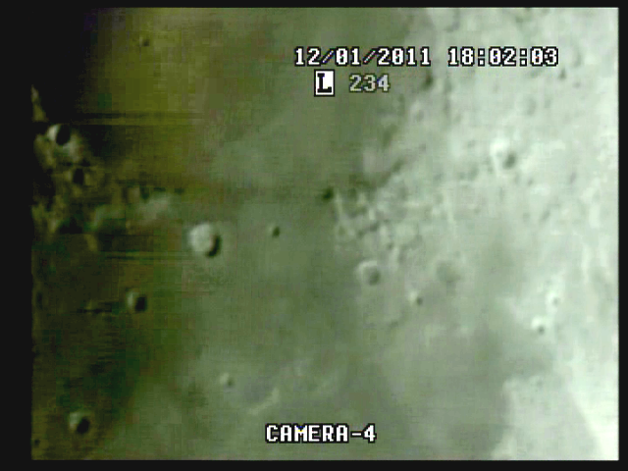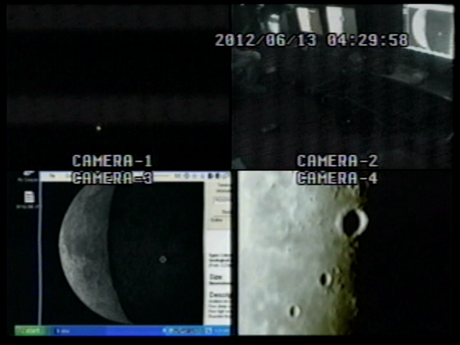

BOS 04:00:00 Quad

Acq of signal at 4:02:51 Quad due to obstruction in East

Time fix at 4:03:01 Quad = 9h03m CUT = 2m47s elapsed

EOS at 5:09:45 Quad

MISSION PLAN:
Routine scans with 73.4% illumination / phase 62.1
Lunar range at 363,579 km / 226.000 miles / lunation 10.09 days / colongitude 34.7
Simrange 600 miles
Good imaging with good WWV

Camera 1 mini finder
Camera 2 Cargo cams (1 &2)
Camera 3 LPI/VMA graphics. (LPI not used)
Camera 4: SSI/CCD/ C-8.
. .
CAMERAS:

CAMERA ONE POSITION ON QUAD
* Finder: mini cam
CAMERA TWO POSITION
* Cargo cameras color minicam & night vision

CAMERA THREE POSITION

Compaq Presario sr1218nx computer (1)
Digital to Analog Converter 1; TEP-100 Elite Pro II
VIRTUAL MOON ATLAS graphics

CAMERA FOUR POSITION

Dell computer
Digital to Analog Converter 2: TEP-100 Elite Pro II
Aperture video recorder DVR2
No graphics used

All camera outputs to Quad / VHS1 / Q Select DVR1

SSI Camera
CCD, (Celestron Neximage Solar System Imager / Charge Coupled Device)
OPTICS, prime focus. 5 mm
VGA resolution (640x480) color ¼” CMOS chip
30 fps
Compression 1420

LPI Camera
Not used
CMOS, (Meade Lunar Planetary Imager / complementary metal oxide semiconductor)
OPTICS, prime focus. 6 mm.
VGA resolution (640x480) color ¼” CMOS chip
30 fps
Compression 1420

Celestron C-8 SCT 8” optical tube
2032 mm f/l
F10
Resolution at lunar range = 0.68 /
.81086 mi or 4281.36469 feet
(30.19' X 60 = 1811.4" /.68' resol = factor of 2663.82353
2160 miles / 2663.82353 = .81086 mi resolution)

0.621 mi/km
1 m = 3.28 ‘

CONFIG
No diagonal or binoc viewer. Extended hand control DOB Driver II

REPORT NOTES

BOS 4:00:00 Quad due to obstruction to the East

Good A/V with WWVR near Moonbuggy, no ant

Good recordings except for late start with DVR1. Apparent malfunction on startup. Also no audio on recording.

Good A/V on VCR1,3, DVR2

Time fix at 8H3m CUT = 1:02:12 Elapsed = 5:03 AM

Cap 061

EOS elapsed 1:09:25

No anomalies observed.

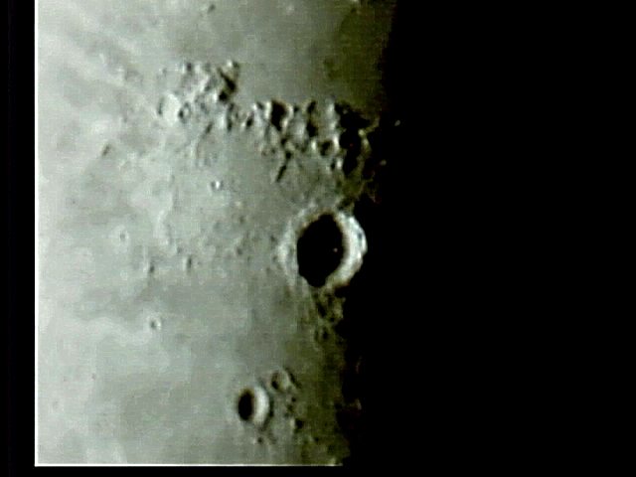

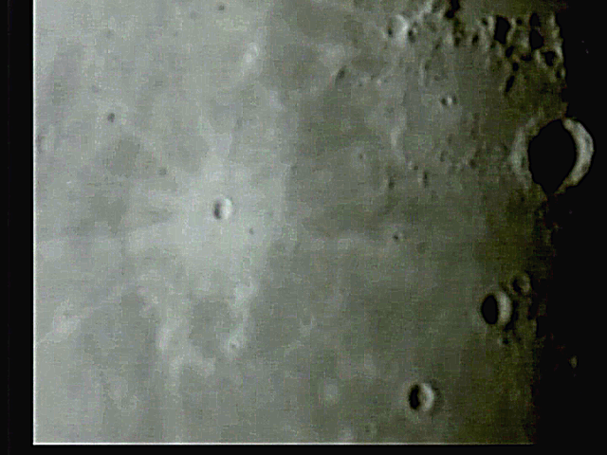

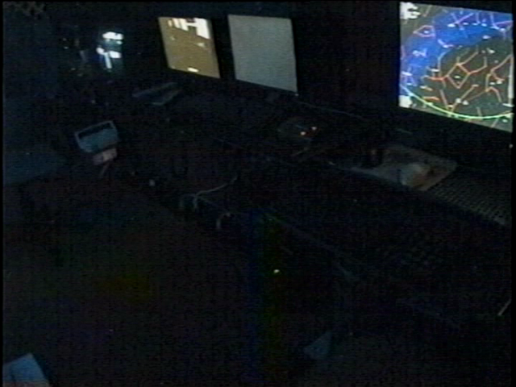

SUGGESTIONS

Position marker on Quad cam1 pos

Check out DVR1 for startup and audio

Shorten line to cargo cam VCR3 and use line on Findercam

2032 mm / 5 mm = 400x . = 600 mi sim range

1. Compaq Presario sr1218nx
XP home, dvd rom, cd burner, 2.67 GHZ processor, 760 mb RAM, 80 GB hard drive
T

