The Lunascan Project - MOONWATCH - Team Report
July 11, 2012
TARGETS: | Western Hemisphere | Multiple Targets

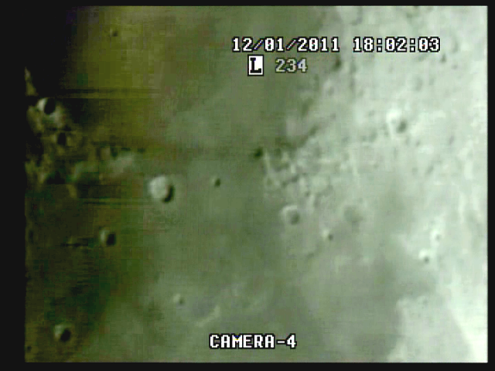
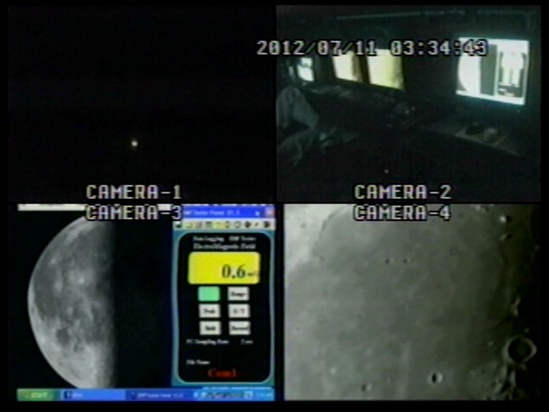

Grab from 03:34:43

BOS = 03:00:45 Quad

CREW
Fran Ridge

MISSION PLAN:
Date: 2012-07-11 02:00:00
Distance: 400114Km / 248,470 miles
Apparent diameter: 29.87'
Colongitude: 177.7°
Phase: 268.2°
Lunation: 21.62 days
Illumination: 48.4%
Simrange 600 miles

Camera 1 mini finder
Camera 2 Cargo cams (1 &2)
Camera 3 LPI/VMA graphics. (LPI not used)
Camera 4: SSI/CCD/ C-8.
. .
CAMERAS:

CAMERA ONE POSITION ON QUAD
* Finder: mini cam
CAMERA TWO POSITION
* Cargo cameras color minicam & night vision

CAMERA THREE POSITION

Compaq Presario sr1218nx computer (1)
Digital to Analog Converter 1; TEP-100 Elite Pro II
VIRTUAL MOON ATLAS graphics left
EM Datalogger right (new)

CAMERA FOUR POSITION

Dell computer
Digital to Analog Converter 2: TEP-100 Elite Pro II
Aperture video recorder DVR2
No graphics used

All camera outputs to Quad / VHS1 / Q Select DVR1

SSI Camera
CCD, (Celestron Neximage Solar System Imager / Charge Coupled Device)
OPTICS, prime focus. 5 mm
VGA resolution (640x480) color ¼” CMOS chip
30 fps
Compression 1420

LPI Camera
Not used
CMOS, (Meade Lunar Planetary Imager / complementary metal oxide semiconductor)
OPTICS, prime focus. 6 mm.
VGA resolution (640x480) color ¼” CMOS chip
30 fps
Compression 1420

Celestron C-8 SCT 8” optical tube
2032 mm f/l
F10
Resolution at lunar range = 0.68 /
.81086 mi or 4281.36469 feet
(30.19' X 60 = 1811.4" /.68' resol = factor of 2663.82353
2160 miles / 2663.82353 = .81086 mi resolution)

0.621 mi/km
1 m = 3.28 ‘

CONFIG
No diagonal or binoc viewer. Extended hand control DOB Driver II

REPORT NOTES
Moderate imaging (haze) with limb less than sharp
No WWV signal due to noise level. Tuneable receiver near van.
Street position
Venus and Jupiter imaged at EOS

EMF datalogger injection with VMA graphics was very successful

Good A/V on VCR1,3, DVR2

Quad

03:00:45Q BOS w/o Moon on Cam 4

03:04:28Q Target acq at 3:47:00 elapsed

04:36:26Q Loss of target (Moon) when mission switched to Venus

04:41:04Q Flash of Venus

04:41:41Q Steady live image of Venus 1:46:00 elapsed

Capture 064 at 1:40:54 elapsed

DVR2

Venus flash at 1:41:07 elapsed

Steady at 1:41:44 elapsed

Jupiter acq at 1h46m25s elapsed:

Time fix therefore is Cam 4 start as 2:59:57 Q

VHS1 48 secs later at 3:00:45Q

Analysis of DVR as follows:

LOS at 1h02m10s elapsed

Regain at 1h07m00s elapsed

.

SUGGESTIONS

Inject manual time fix notation with WT and scanner.

Use binoc e/p adaptor to lower light level and have e/p for finding targets.

Aperture video VHS3 used on Cargo cams

Video splitter on finder so that night vision of sky can be recorded on Cam 1 position on Q

1. Compaq Presario sr1218nx
XP home, dvd rom, cd burner, 2.67 GHZ processor, 760 mb RAM, 80 GB hard drive
T

