The Lunascan Project - MOONWATCH - Team Report
July 25, 2012
TARGETS: | Eastern Hemisphere | Multiple Targets

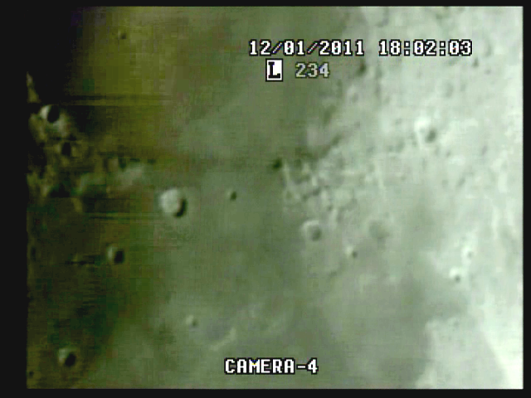

BOS

CREW COMPLIMENT:
Fran Ridge

MISSION PLAN:
Wednesday
25 July 2012 Central Daylight Time
SUN
Begin civil twilight 5:18 a.m. NA
Sunrise 5:48 a.m. NA
MOON
Moonset 11:01 p.m. on preceding day
Moonrise 12:43 p.m.

Date: 2012-07-25 21:00:00 (9 PM)
Distance: 367925Km
Apparent diameter: 32.48'
Colongitude: 358.7
Phase: 94.3
Lunation: 6.86 days
Illumination: 46.3%
Simrange 600 miles

Camera 1 mini finder
Camera 2 Cargo cams
Camera 3 VMA graphics/T1392 E-M Datalogger/LPI (LPI not used)
Camera 4: SSI/CCD/ C-8.
. .
CAMERAS:

CAMERA ONE POSITION ON QUAD
* Finder: mini cam
CAMERA TWO POSITION
* CabCam color minicam/w illum blue instr lights
* CabCam camera w/night vision hardlined to lab

CAMERA THREE POSITION

Compaq Presario sr1218nx computer (1)
Digital to Analog Converter 1; TEP-100 Elite Pro II
VIRTUAL MOON ATLAS graphics left
EM DATALOGGER T1392 right set for
( X ) MilliGauss ( ) MicroTesla
( ) KII on rod for CabCam pickup

CAMERA FOUR POSITION

Dell computer
Digital to Analog Converter 2: TEP-100 Elite Pro II
Aperture video recorder DVR2
No graphics used

All camera outputs to Quad / VHS1 / Q Select DVR1

SSI Camera
CCD, (Celestron Neximage Solar System Imager / Charge Coupled Device)
OPTICS, prime focus. 5 mm
VGA resolution (640x480) color ¼” CMOS chip
30 fps
Compression 1420

LPI Camera
Not used
CMOS, (Meade Lunar Planetary Imager / complementary metal oxide semiconductor)
OPTICS, prime focus. 6 mm.
VGA resolution (640x480) color ¼” CMOS chip
30 fps
Compression 1420

Celestron C-8 SCT 8” optical tube
2032 mm f/l
F10
Resolution at lunar range = 0.68 /
.81086 mi or 4281.36469 feet
(30.19' X 60 = 1811.4" /.68' resol = factor of 2663.82353
2160 miles / 2663.82353 = .81086 mi resolution)

0.621 mi/km
1 m = 3.28 ‘

CONFIG
( ) Diagonal and ( ) binoc viewer. Extended hand control DOB Driver II

REPORT NOTES

QUAD

DataDisc from VHS1

START at 21:08:19 Q

CabCam is ON Cam 2 Pos

VMA/EM Datalogger is ON Cam 3 pos DL set at mTesla

Neg WWV or SW carrier

WT is working, time fix verifies Q time

FinderCam is ON & target onscreen at 21:09:16 Q

SSI (Cam4) is ON & focused at 2m46s elapsed = 21:11:04 Q

Cap 009 is Quad data full

WT Time Fix at

1h30m51s el = 22:39:15 CUT Cam 4 OFF

EOS

DVR2
Very good imaging with limb slightly less than sharp
WWV signal very good but intermittant. Tuneable receiver near van on batts.
DW position

EMF datalogger injection with VMA graphics set on microTesla first hour then switched to milliGauss.

Meade Barlow inserted in telescope back then SSI cam. Doubled image with some blur due to sky conditions.

Good A/V on VCR1,3, DVR2

Quad Select

DVR2

3m21s elapsed target acquisition

Good volume on audio but no WWV carrier

Sharp limb

Capture 001 rays 12m19s el

Good WWV at 17m09s el

Time fix at 2h38m CUT 29m54s el

Barlow 30m37s el

Normal 36m00s el

WT inaudible

LOT & stop

Time fix 3h5m CUT was 56m53s el

Cap 005 = ray connections

3h27m CUT = 1h18m53s el

LOT

Reestablished 1h22m25s el Barlow 2X

Back to normal 1h24m57s el

1h31m13s el

LOT

Cargo

Good video. Bad sound connection/little or no audio.

Analysis of DVR1 as follows:

SUGGESTIONS

1. Compaq Presario sr1218nx
XP home, dvd rom, cd burner, 2.67 GHZ processor, 760 mb RAM, 80 GB hard drive
T

