The Lunascan Project - MOONWATCH - Team Report
August 9, 2012
TARGETS: | Western Hemisphere | Multiple Targets

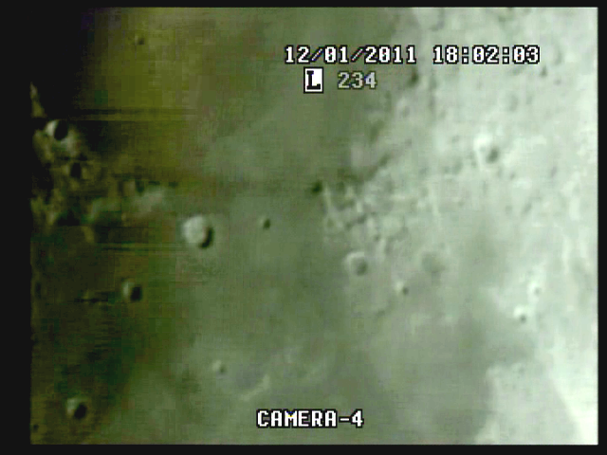
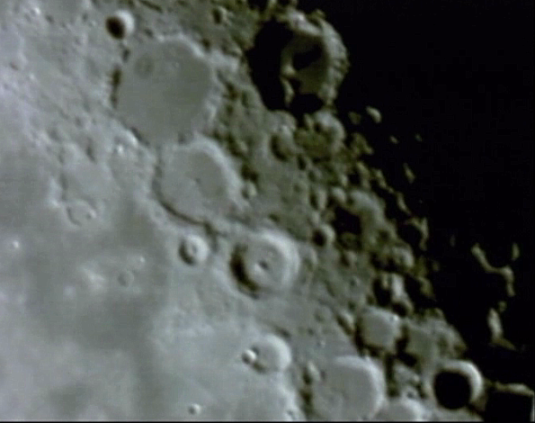

BOS 3:24:44 Quad time (3:24 AM)

CREW COMPLIMENT:
Fran Ridge

MISSION PLAN:
Early morning session. See Rise/Set report and VMA data attached.

Camera 1 mini finder
Camera 2 Cargo cam
Camera 3 VMA graphics/T1392 E-M Datalogger/LPI (LPI not used)
Camera 4: SSI/CCD/ C-8.
. .
CAMERAS:

CAMERA ONE POSITION ON QUAD
* Finder: mini cam
CAMERA TWO POSITION
* CabCam color minicam/w illum blue instr lights
* CabCam camera w/night vision hardlined to lab

CAMERA THREE POSITION

Compaq Presario sr1218nx computer (1)
Digital to Analog Converter 1; TEP-100 Elite Pro II
VIRTUAL MOON ATLAS graphics left
EM DATALOGGER T1392 right set for
( X ) MilliGauss ( ) MicroTesla
( ) KII on rod for CabCam pickup

CAMERA FOUR POSITION

Dell computer
Digital to Analog Converter 2: TEP-100 Elite Pro II
Aperture video recorder DVR2
No graphics used

All camera outputs to Quad / VHS1 / Q Select DVR1

============================================================

SSI Camera

SSI or A camera = 2032/5=400x
No Barlow or focal reducer used
delivers a simrange of 600 mi and FOV of 400 miles
CCD sensor
Charge Coupled Device
Celestron Neximage Solar System Imager
Type HAD (1/4")
OPTICS, prime focus 5 mm
Active area 3.6mm x 2.7 (4.5 mm diagonal)
Pixel size 5.6 micron, square
VGA resolution (640x480) color ¼” CCD chip
Maximum usable framerate @ 640x480
(uncompressed): 30 fps
Compression 1420
?-Bit on-chip A/D converter
3 MP
Sensitivity <1 lux
ACOMP Computer
Dell, Intel Pentium 4 processor
2 Gigahertz, 256 meg RAM
C Drive, 40 GB
D Drive, 111 GB

===============================================================

LPI Camera NOT UTILIZED

LPI or B camera = 2032/6=340x
with the focal reducer = 340/2=170x
increasing simrange to 1400 mi and FOV to 900 mi
CMOS sensor by Hynix ~310kPix, (Bayer matrix)
Complementary Metal Oxide Semiconductor Semiconductor Inc.
Meade Lunar Planetary Imager
Type HV7131E1 (1/3")
OPTICS, prime focus. 6 mm.
Active area 5.18x3.90 mm (6.5 mm diagonal)
Pixel size 8.0 micron, square
VGA resolution (640x480) color
Max usable framerate @ 640x480
(uncompressed): 36 fps
Compression 1420
8-Bit on-chip A/D converter
1.3 MP
Sensitivity <?lux
BCOMP Computer
Compaq Presario sr1218nx XP Home
2.67 GHZ processor, 760 mb RAM,
C Drive 80 GB hard drive

======================================================

Celestron C-8 SCT 8” optical tube
2032 mm f/l
F10
Resolution at lunar range = 0.68 /
.81086 mi or 4281.36469 feet
(30.19' X 60 = 1811.4" /.68' resol = factor of 2663.82353
2160 miles / 2663.82353 = .81086 mi resolution)

0.621 mi/km
1 m = 3.28 ‘

CONFIG
(X) SSI in scope back
( ) Diagonal and ( ) binoc viewer. Extended hand control DOB Driver II

REPORT NOTES

QUAD

3h24m44s Quad

No apparent carrier

WT working but WWV out

Good images

3h30m16s target acquisition and focus

4h44m11s LOS

Q-SELECT

3h26m43s

Good images

No carrier, possible WT if necessity arises

DVR2

Scan Duration 1:24:56

Target Acq and focus at 8m31s elapsed = 3h30m16s Quad (3:30 AM)

Numerous DM (Dust Mites)

Good carrier but no WWV

Atmospheric Turbulence

21:22:00 el images improving

29:06:00 el Cap 006, 007, (Tycho) 008

Time Fix 040105 WT = 39m22s el

Loss of track (slippage) 1h00m57s

1h22m00s el slippage

EOS

CABCAM

Good images and carrier but no signal

Possible time fix from WT

Analysis of DVR1 as follows:

Problems with audio feeds but imaging good. No anomalies observed or recorded.

SUGGESTIONS
Recheck audio feeds, connect via L2 inputs for easy access.

