The Lunascan Project - MOONWATCH - Team Report
August 10, 2013
TARGETS: | E Hemisphere | IMPACT Mission

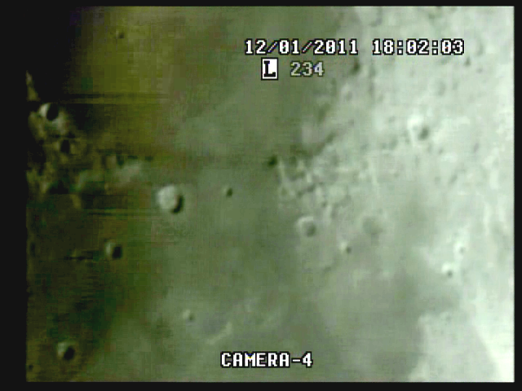
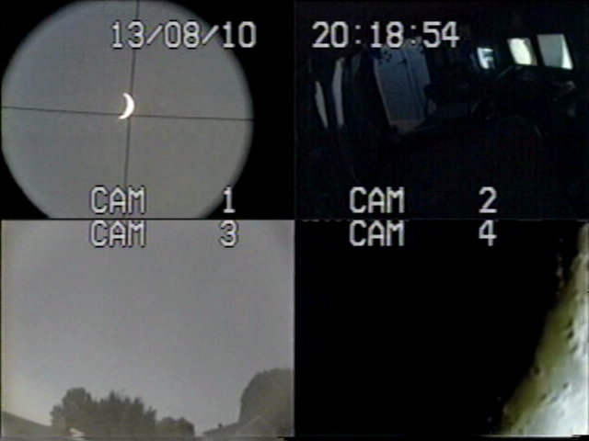

BOS

20:11:53 (8:11 PM)

Durat = 44 mins

EOS

20:11:55 (8:55 PM)

Data tapes rolling at 20:11:00 and target acquisition 2m48s later over Mare Crisium. Mission duration: 44 minutes as target was obscured by trees in the west. Excellent time fixes with WWV from receiver in lab. No impacts observed during the mission nor during lab screening. End of lunar portion of mission at 20:55. SkyCam set up for incoming meteors orientation NE was allowed to run until tapes ran out at 22:11 approx.

Test of new AV board was successful.

DATA MOON:
Ephemeris for datetime attached.

CREW COMPLIMENT:
Fran Ridge

EQUIPMENT
RECORDERS
VHS1 on LIMA 2 (Quad)
VHS2 on LIMA 2 (VMA/SkyCam IR [B Cam] on Quad Cam 3 position)
VHS3 on LIMA 2 (CabCam, color, Quad Camera 2 position)
DVR1 on LIMA 2 (Q Sel)
DVR2 on LIMA 1 [default] (SSI Camera, Quad Cam 4 position)

QUAD CAMERA POSITIONS:
All camera outputs to Quad SAMSUNG SCQ-041P
Camera 1 mini finders (SC-NVA5’s), A (wide angle) & B (9x50 #51611 Celestron finder w/crosshairs)
Y=video R=power
Camera 2 CabCam cam 1 (color, SC-NVA5 to Quad), cam 2 (Sony CL-34S-2T, night vision, security, to Lab via RG59)
Camera 3 VMA graphics/T1392 E-M Datalogger/SkyCam IR (LPI / C8 (LPI not used)
Camera 4: SSI/C-8. .
COMPUTERS:
PC1 System
Dell Intel Pentium 4 processor
2 Gigahertz, 256 meg RAM
C Drive, 40 GB
D Drive, 111 GB
Digital to Analog Converter 2: TEP-100 Elite Pro II
Aperture video recorder DVR2
No graphics used
Feeding Quad Cam Position 4

PC2 System
Compaq Presario sr1218nx computer (1)
Digital to Analog Converter 1; TEP-100 Elite Pro II
VIRTUAL MOON ATLAS graphics left
EM DATALOGGER T1392 right set for
( X ) MilliGauss ( ) MicroTesla
( ) KII on rod for CabCam pickup
Aperture video recorder VHS2
Feeding Quad Cam Position 3

CAMERAS:
Camera 1
Celestron Neximage Solar System Imager
SSI or A camera = 2032/5=400x
No Barlow or focal reducer used
delivers simrange of 600 mi and FOV of 400 miles
CCD sensor (Charge Coupled Device)
Type HAD (1/4")
OPTICS, prime focus 5 mm
Active area 3.6mm x 2.7 (4.5 mm diagonal)
Pixel size 5.6 micron, square
VGA resolution (640x480) color ¼” CCD chip
Maximum usable framerate @ 640x480
(uncompressed): 30 fps
#11 yellow written filter
Compression 1420
?-Bit on-chip A/D converter
3 MP
Sensitivity <1 lux
ACOMP Computer

Camera 2
LPI (NOT UTILIZED THIS MISSION)
LPI or B camera = 2032/6=340x
CMOS sensor by Hynix ~310kPix, (Bayer matrix), Complementary Metal Oxide Semiconductor Semiconductor Inc.
Meade Lunar Planetary Imager
Type HV7131E1 (1/3")
OPTICS, prime focus. 6 mm.
Active area 5.18x3.90 mm (6.5 mm diagonal)
Pixel size 8.0 micron, square
VGA resolution (640x480) color
Max usable framerate @ 640x480
(uncompressed): 36 fps
Compression 1420
8-Bit on-chip A/D converter
1.3 MP
Sensitivity <?lux
BCOMP Computer
Compaq Presario sr1218nx XP Home
2.67 GHZ processor, 760 mb RAM,
C Drive 80 GB hard drive

OPTICAL TUBE:
Celestron C-8 SCT 8” optical tube
2032 mm f/l
F10
Resolution at lunar range = 0.68 /
.81086 mi or 4281.36469 feet
(30.19' X 60 = 1811.4" /.68' resol = factor of 2663.82353
2160 miles / 2663.82353 = .81086 mi resolution)0.621 mi/km
1 m = 3.28 ‘

SKYCAMS
Camera 3, CX480
Camera 4, GBC400

CONFIG:
(X) SSI in scope back
( ) Diagonal and ( ) binoc viewer. Extended hand control DOB Driver II

