The Lunascan Project - MOONWATCH - Team Report
August 11, 2013
TARGETS: | E Hemisphere | IMPACT Mission

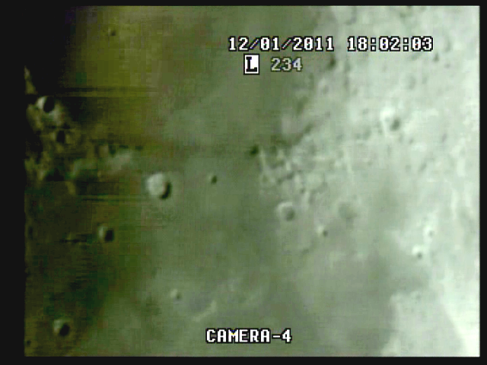
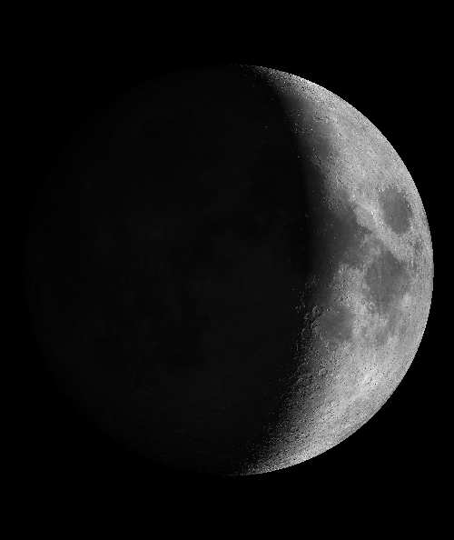
Range 390,390 km, colong 329.5, phase 126.6, illumination 20.2%

VHS1/QUAD
20130811 Date error on Quad says 14/08/10, s/b 13/08/11. Corrected.
0:00:21 elapsed 1h0m CUT Time fix
8:02:24 PM CDT = 20:02:24 Q Target Acquisition
8:02:56 PM CDT = 20:02:56 Q 0:03:20 elapsed 1h03m CUT Time fix within 4 secs!
8:30:10 PM CDT = 0:30:33 elapsed Cap 9
9:20:22 PM CDT = 0:20:41 Cam 4 position
1:26:56 elapsed LOT after 6m15s
9:56:36 PM CDT = 21:59:36 Q EO SkyCam

DVR2/SSI CAM
20130811 8:02 PM CDT (20:02:05) Q 0:00:00 elapsed No target
0:02:20 elapsed Target Acq
(20:02:56) Q 0:02:51 elapsed 1h03m CUT Time fix
0:05:17 elapsed Cap 07 Posidonius
0:11:07 elapsed Cap 08 Terminator ^ Theophilus
0:38:34 elapsed LOT due to USB / pc re-booted twice
1:20:14 elapsed BOT after 42 mins
1:26:23 elapsed LOT / EOM (SSI)
No anomalies, impacts or fastwalkers observed or recorded.

DVR1/QUAD SELECT
Good WWW and Quad time fix. Excellent data recordings. None selected for capture.

VHS3/CABCAMREC
No data. Tape separated from reel. Some clips archived on QS

SKYCAM DATA
No analyzed this date

DATA MOON:
Ephemeris for datetime attached.

CREW COMPLIMENT:
Fran Ridge

EQUIPMENT
RECORDERS
VHS1 on LIMA 2 (Quad)
VHS2 on LIMA 2 (VMA/SkyCam IR [B Cam] on Quad Cam 3 position)
VHS3 on LIMA 2 (CabCam, CL-34S-2T 60’ IR, color, Quad Camera 2 position)
DVR1 on LIMA 2 (Q Sel)
DVR2 on LIMA 1 [default] (SSI Camera, Quad Cam 4 position)

QUAD CAMERA POSITIONS:
All camera outputs to Quad SAMSUNG SCQ-041P
Camera 1 mini finders (SC-NVA5’s), A (wide angle) & B (9x50 #51611 Celestron finder w/crosshairs)
Y=video R=power
Camera 2 CabCam cam 1 (color, SC-NVA5 to Quad), cam 2 (Sony CL-34S-2T, night vision, security, to Lab via RG59)
Camera 3 LPI (not utilized), VMA graphics/T1392 E-M Datalogger/SkyCam IR (LPI / C8 (LPI not used)
Camera 4: SSI/C-8. .
COMPUTERS:
PC1 System
Dell Intel Pentium 4 processor
2 Gigahertz, 256 meg RAM
C Drive, 40 GB
D Drive, 111 GB
Digital to Analog Converter 2: TEP-100 Elite Pro II
Aperture video recorder DVR2
No graphics used
Feeding Quad Cam Position 4

PC2 System
Compaq Presario sr1218nx computer (1)
Digital to Analog Converter 1; TEP-100 Elite Pro II
VIRTUAL MOON ATLAS graphics left
EM DATALOGGER T1392 right set for
( X ) MilliGauss ( ) MicroTesla
( ) KII on rod for CabCam pickup
Aperture video recorder VHS2
Feeding Quad Cam Position 3

CAMERAS:
Camera 1
Celestron Neximage Solar System Imager
SSI or A camera = 2032/5=400x
No Barlow or focal reducer used
delivers simrange of 600 mi and FOV of 400 miles
CCD sensor (Charge Coupled Device)
Type HAD (1/4")
OPTICS, prime focus 5 mm
Active area 3.6mm x 2.7 (4.5 mm diagonal)
Pixel size 5.6 micron, square
VGA resolution (640x480) color ¼” CCD chip
Maximum usable framerate @ 640x480
(uncompressed): 30 fps
#11 yellow written filter
Compression 1420
?-Bit on-chip A/D converter
3 MP
Sensitivity <1 lux
ACOMP Computer

Camera 2
LPI (NOT UTILIZED THIS MISSION)
LPI or B camera = 2032/6=340x
CMOS sensor by Hynix ~310kPix, (Bayer matrix), Complementary Metal Oxide Semiconductor Semiconductor Inc.
Meade Lunar Planetary Imager
Type HV7131E1 (1/3")
OPTICS, prime focus. 6 mm.
Active area 5.18x3.90 mm (6.5 mm diagonal)
Pixel size 8.0 micron, square
VGA resolution (640x480) color
Max usable framerate @ 640x480
(uncompressed): 36 fps
Compression 1420
8-Bit on-chip A/D converter
1.3 MP
Sensitivity <?lux
BCOMP Computer
Compaq Presario sr1218nx XP Home
2.67 GHZ processor, 760 mb RAM,
C Drive 80 GB hard drive

OPTICAL TUBE:
Celestron C-8 SCT 8” optical tube
2032 mm f/l
F10
Resolution at lunar range = 0.68 /
.81086 mi or 4281.36469 feet
(30.19' X 60 = 1811.4" /.68' resol = factor of 2663.82353
2160 miles / 2663.82353 = .81086 mi resolution)0.621 mi/km
1 m = 3.28 ‘

Camera 3, CX480
Camera 4, GBC400

CONFIG:
(X) SSI in scope back
( ) Diagonal and ( ) binoc viewer. Extended hand control DOB Driver II

SKYCAMS:
CX480-SR40, 40’IR
GBC-400 (Not used)

