The Lunascan Project - MOONWATCH - Team Report
August 13, 2013
TARGETS: | E Hemisphere | IMPACT Mission

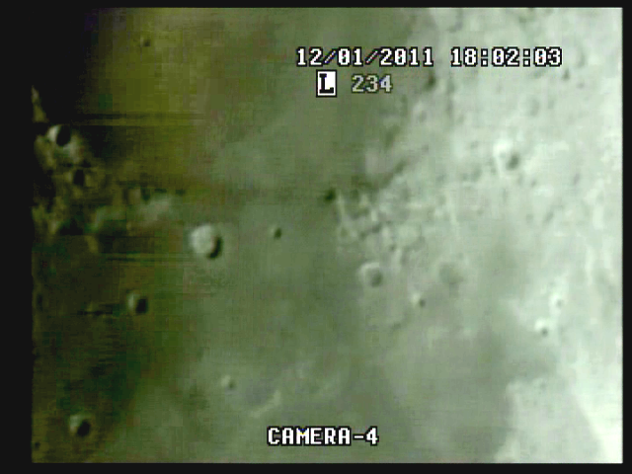

Range 374,714 km, colong 2.2, phase 93.5, illumination 47%

20130813 8:26 PM
QUAD/VHS1
Target ACQ 20:26:43 Q 1h30m CUT & GBC-400 on Cam 3
LOT at 22:02:42 Q, 1:35:55 ETI, 3h5m CUT
Q-SELECT/DVR1
LOT (USB?) at 20:33:10 Q, 0:21:49 ETI, 1h29m CUT
Time fix at 21:11:43 Q, 1:00:20 ETI, 2h15m CUT
Strobes on cam 3 at 21:17:05 Q
Good strobe at 21:51:05, 1:39:40 ETI
Finalize on Cam 4 at 22:08:45 Q, 3h31m CUT
CAM 4 (SSI)/DVR
0:12:15 ETI, 1h26m CUT,Target Acq
0:22:37 ETI, LOT (22:37 to 27:34)
0:28:14 ETI bird
0:30:15 ETI, 1h44m CUT, time fix
0:38:04 ETI Cap 11 (bug near objective ????)
0:39:10 ETI Cap 12 terminator shot
0:42:15 ETI clouds
0:47:30 ETI LOT (USB, clouds or both)
0:53:50 ETI AOT and better images
0:56:25 ETI Cap 13
0:58:16 ETI Cap 14
1:15:28 ETI Cap 15
1:33:11 ETI 2h47 CUT Deteoriation then clearing
1:57:25 ITI EOS

DATA MOON:
Ephemeris for datetime attached.

CREW COMPLIMENT:
Fran Ridge

EQUIPMENT
RECORDERS
VHS1 on LIMA 2 (Quad)
VHS2 on LIMA 2 (VMA/SkyCam IR [B Cam] on Quad Cam 3 position)
VHS3 on LIMA 2 (CabCam, CL-34S-2T 60’ IR, color, Quad Camera 2 position)
DVR1 on LIMA 2 (Q Sel)
DVR2 on LIMA 1 [default] (SSI Camera, Quad Cam 4 position)

QUAD CAMERA POSITIONS:
All camera outputs to Quad SAMSUNG SCQ-041P
Camera 1 mini finders (SC-NVA5’s), A (wide angle) & B (9x50 #51611 Celestron finder w/crosshairs)
Y=video R=power
Camera 2 CabCam cam 1 (color, SC-NVA5 to Quad), cam 2 (Sony CL-34S-2T, night vision, security, to Lab via RG59)
Camera 3 LPI (not utilized), VMA graphics/T1392 E-M Datalogger/SkyCam IR (LPI / C8 (LPI not used)
Camera 4: SSI/C-8. .
COMPUTERS:
PC1 System
Dell Intel Pentium 4 processor
2 Gigahertz, 256 meg RAM
C Drive, 40 GB
D Drive, 111 GB
Digital to Analog Converter 2: TEP-100 Elite Pro II
Aperture video recorder DVR2
No graphics used
Feeding Quad Cam Position 4

PC2 System
Compaq Presario sr1218nx computer (1)
Digital to Analog Converter 1; TEP-100 Elite Pro II
VIRTUAL MOON ATLAS graphics left
EM DATALOGGER T1392 right set for
( X ) MilliGauss ( ) MicroTesla
( ) KII on rod for CabCam pickup
Aperture video recorder VHS2
Feeding Quad Cam Position 3

CAMERAS:
Camera 1
Celestron Neximage Solar System Imager
SSI or A camera = 2032/5=400x
No Barlow or focal reducer used
delivers simrange of 600 mi and FOV of 400 miles
CCD sensor (Charge Coupled Device)
Type HAD (1/4")
OPTICS, prime focus 5 mm
Active area 3.6mm x 2.7 (4.5 mm diagonal)
Pixel size 5.6 micron, square
VGA resolution (640x480) color ¼” CCD chip
Maximum usable framerate @ 640x480
(uncompressed): 30 fps
#11 yellow written filter
Compression 1420
?-Bit on-chip A/D converter
3 MP
Sensitivity <1 lux
ACOMP Computer

Camera 2
LPI (NOT UTILIZED THIS MISSION)
LPI or B camera = 2032/6=340x
CMOS sensor by Hynix ~310kPix, (Bayer matrix), Complementary Metal Oxide Semiconductor Semiconductor Inc.
Meade Lunar Planetary Imager
Type HV7131E1 (1/3")
OPTICS, prime focus. 6 mm.
Active area 5.18x3.90 mm (6.5 mm diagonal)
Pixel size 8.0 micron, square
VGA resolution (640x480) color
Max usable framerate @ 640x480
(uncompressed): 36 fps
Compression 1420
8-Bit on-chip A/D converter
1.3 MP
Sensitivity <?lux
BCOMP Computer
Compaq Presario sr1218nx XP Home
2.67 GHZ processor, 760 mb RAM,
C Drive 80 GB hard drive

OPTICAL TUBE:
Celestron C-8 SCT 8” optical tube
2032 mm f/l
F10
Resolution at lunar range = 0.68 /
.81086 mi or 4281.36469 feet
(30.19' X 60 = 1811.4" /.68' resol = factor of 2663.82353
2160 miles / 2663.82353 = .81086 mi resolution)0.621 mi/km
1 m = 3.28 ‘

Camera 3, CX480
Camera 4, GBC400

CONFIG:
(X) SSI in scope back
( ) Diagonal and ( ) binoc viewer. Extended hand control DOB Driver II

SKYCAMS:
CX480-SR40, 40’IR
GBC-400 (Not used)

