The Lunascan Project - MOONWATCH - Team Report
October 9, 2013
TARGETS: Theophilus | Eastern Limb | RSM (Routine Scanning Mission)

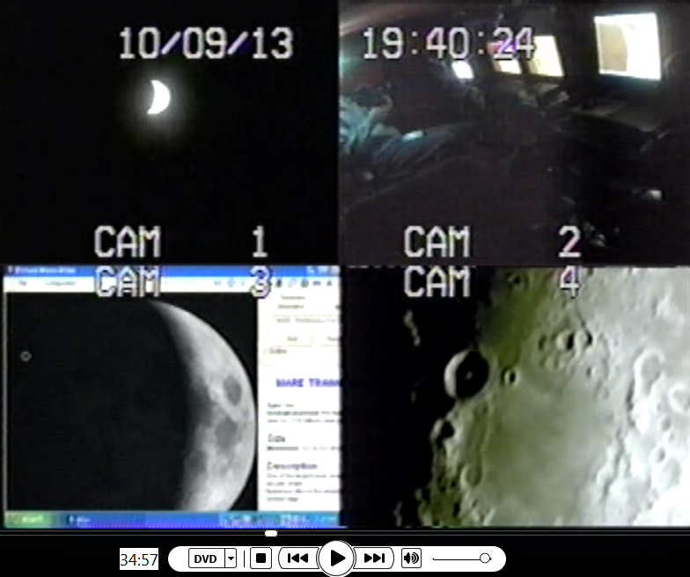

1. PRELIMINARY DATA
van
QUAD
0h00m el no targets = 19:05:25 Quad
target acg @ 19:09:25 Q
Image above @ 34m57s el
Good WWV
QSELECT
Tape failure/No CD made
DVRII
Good WWV
04m30s aot
CARGOCAM
Good WWV
Picture grainy but due to night vision & blue lights

2. EPHEMERIS DE421
Ephemeris: DE421
Observatory: +37°34' +87°32' Tz: -4h00m
Date: 2013-10-09 19:05:25
Date (TT): 2013-10-09 23:06:33
(J2000) Right Ascension: 17h17m35.41s
(J2000) Declination: -20°20'44.4"
(Date) Right Ascension: 17h18m24.54s
(Date) Declination: -20°21'27.2"
Distance: 366883Km
Apparent diameter: 32.57'
Colongitude: 335.4°
Phase: 116.2°
Lunation: 4.94 days
Illumination: 28.0%
Sub-solar latitude: -0.6°
Libration in Latitude: -03°45'
Libration in Longitude: -01°42'
Position angle: 5.4°
Azimuth +199°25'
Altitude +29°41'
Rise: 12h43m
Transit: 17h52m
Set: 23h00m
Rise azimuth: +114°57'
Transit Altitude: +32°
Set azimuth: +244°58'
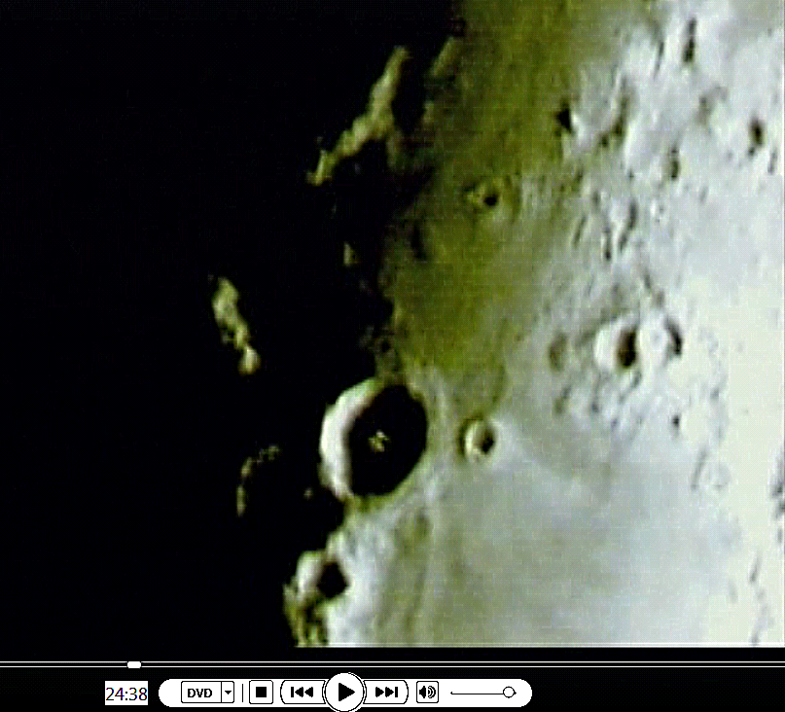
3. ANALYSIS
0h00m el no targets = 19:05:25 Quad
target acg @ 19:09:25 Q
DVRII
04m30s aot
05m35s end of shaky images
24m38s el (see above photo) Theophilus
1h06m41s = 20:12:10 Q
EOM 01h07m13s el = 1h14m CUT
No impacts, anomalies, LTPs or fastwalkers observed

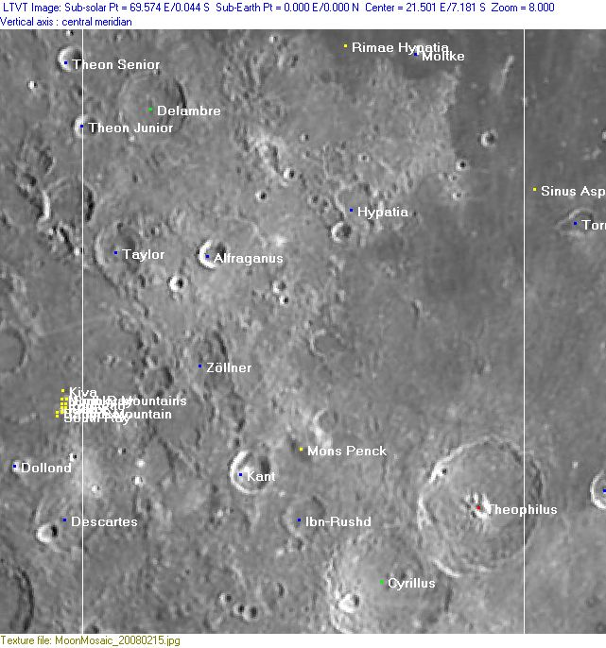

4. EQUIPMENT MODE LEVEL

VHS1/QUAD
DVR2/SSI CAM
DVR1/QUAD SELECT
VHS3/CABCAMREC

SKYCAM DATA
Not used.

DATA MOON:
Ephemeris for date/time attached.

CREW COMPLIMENT:
Fran Ridge

EQUIPMENT
RECORDERS
VHS1 on LIMA 2 (Quad)
VHS2 on LIMA 2 (VMA/SkyCam IR [B Cam] on Quad Cam 3 position)
VHS3 on LIMA 2 (CabCam, CL-34S-2T 60’ IR, color, Quad Camera 2 position)
DVR1 on LIMA 2 (Q Sel)
DVR2 on LIMA 1 [default] (SSI Camera, Quad Cam 4 position)

QUAD CAMERA POSITIONS:
All camera outputs to Quad SAMSUNG SCQ-041P
Camera 1 mini finders (SC-NVA5’s), A (wide angle) & B (9x50 #51611 Celestron finder w/crosshairs)
Y=video R=power
Camera 2 CabCam cam 1 (color, SC-NVA5 to Quad), cam 2 (Sony CL-34S-2T, night vision, security, to Lab via RG59)
Camera 3 LPI (not utilized), VMA graphics/T1392 E-M Datalogger/SkyCam IR (LPI / C8 (LPI not used)
Camera 4: SSI/C-8. .
COMPUTERS:
PC1 System
Dell Intel Pentium 4 processor
2 Gigahertz, 256 meg RAM
C Drive, 40 GB
D Drive, 111 GB
Digital to Analog Converter 2: TEP-100 Elite Pro II
Aperture video recorder DVR2
No graphics used
Feeding Quad Cam Position 4

PC2 System
Compaq Presario sr1218nx computer (1)
Digital to Analog Converter 1; TEP-100 Elite Pro II
VIRTUAL MOON ATLAS graphics left
EM DATALOGGER T1392 right set for
( X ) MilliGauss ( ) MicroTesla
( ) KII on rod for CabCam pickup
Aperture video recorder VHS2
Feeding Quad Cam Position 3

CAMERAS:
Camera 1
Celestron Neximage Solar System Imager
SSI or A camera = 2032/5=400x
No Barlow or focal reducer used
delivers simrange of 600 mi and FOV of 400 miles
CCD sensor (Charge Coupled Device)
Type HAD (1/4")
OPTICS, prime focus 5 mm
Active area 3.6mm x 2.7 (4.5 mm diagonal)
Pixel size 5.6 micron, square
VGA resolution (640x480) color ¼” CCD chip
Maximum usable framerate @ 640x480
(uncompressed): 30 fps
#11 yellow written filter
Compression 1420
?-Bit on-chip A/D converter
3 MP
Sensitivity <1 lux
ACOMP Computer

Camera 2
LPI (NOT UTILIZED THIS MISSION)
LPI or B camera = 2032/6=340x
CMOS sensor by Hynix ~310kPix, (Bayer matrix), Complementary Metal Oxide Semiconductor Semiconductor Inc.
Meade Lunar Planetary Imager
Type HV7131E1 (1/3")
OPTICS, prime focus. 6 mm.
Active area 5.18x3.90 mm (6.5 mm diagonal)
Pixel size 8.0 micron, square
VGA resolution (640x480) color
Max usable framerate @ 640x480
(uncompressed): 36 fps
Compression 1420
8-Bit on-chip A/D converter
1.3 MP
Sensitivity <?lux
BCOMP Computer
Compaq Presario sr1218nx XP Home
2.67 GHZ processor, 760 mb RAM,
C Drive 80 GB hard drive

OPTICAL TUBE:
Celestron C-8 SCT 8” optical tube
2032 mm f/l
F10
Resolution at lunar range = 0.68 /
.81086 mi or 4281.36469 feet
(30.19' X 60 = 1811.4" /.68' resol = factor of 2663.82353
2160 miles / 2663.82353 = .81086 mi resolution)0.621 mi/km
1 m = 3.28 ‘

CONFIG:
(X) SSI in scope back
( ) Diagonal and ( ) binoc viewer. Extended hand control DOB Driver II

SKYCAMS:
CX480-SR40, 40’IR
GBC-400 (Not used)

